My Project: **https://ns-zwbaycgteo.now.sh**

1. Load a page from your server and display something

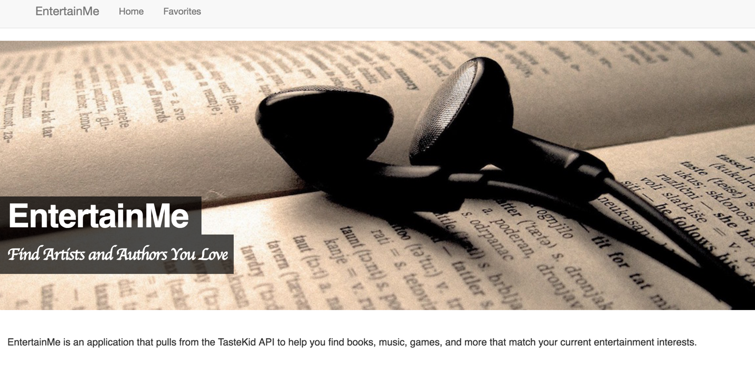

I used HTML, CSS, and JS to create this project. This is an example of loading the description page from my server and displaying something.

1. Button on the first page makes an XML-HTTP Request to parse JSON data and display it to the client.

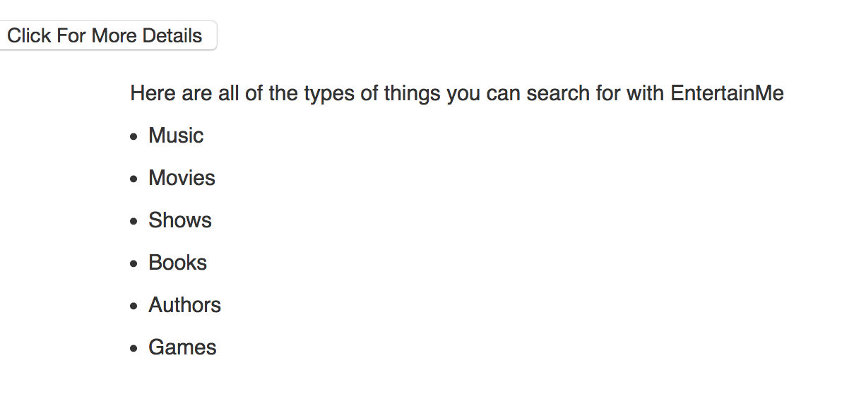

1. Makes AJAX requests to the TasteKid API: <https://www.tastekid.com/read/api>

This form makes the request:



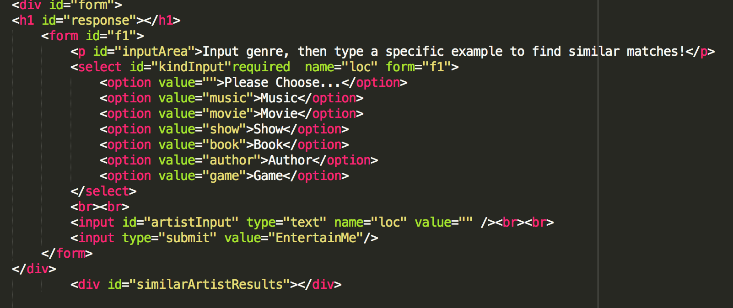

This is the screen update:

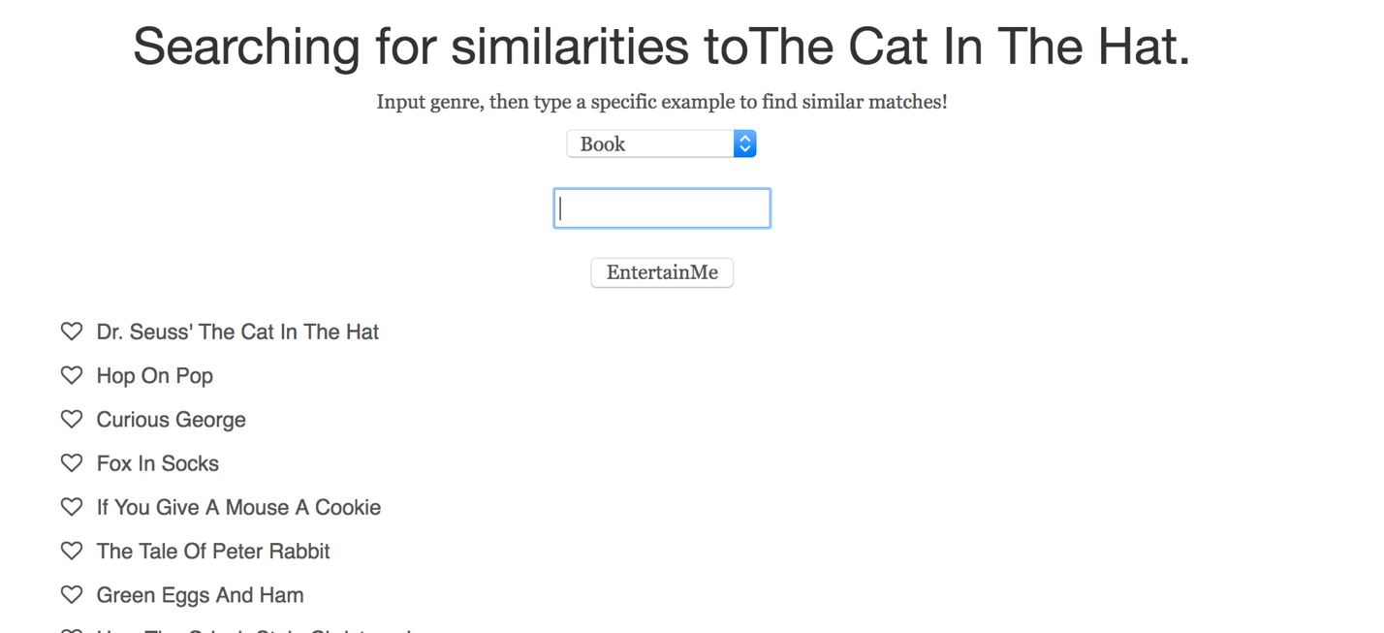

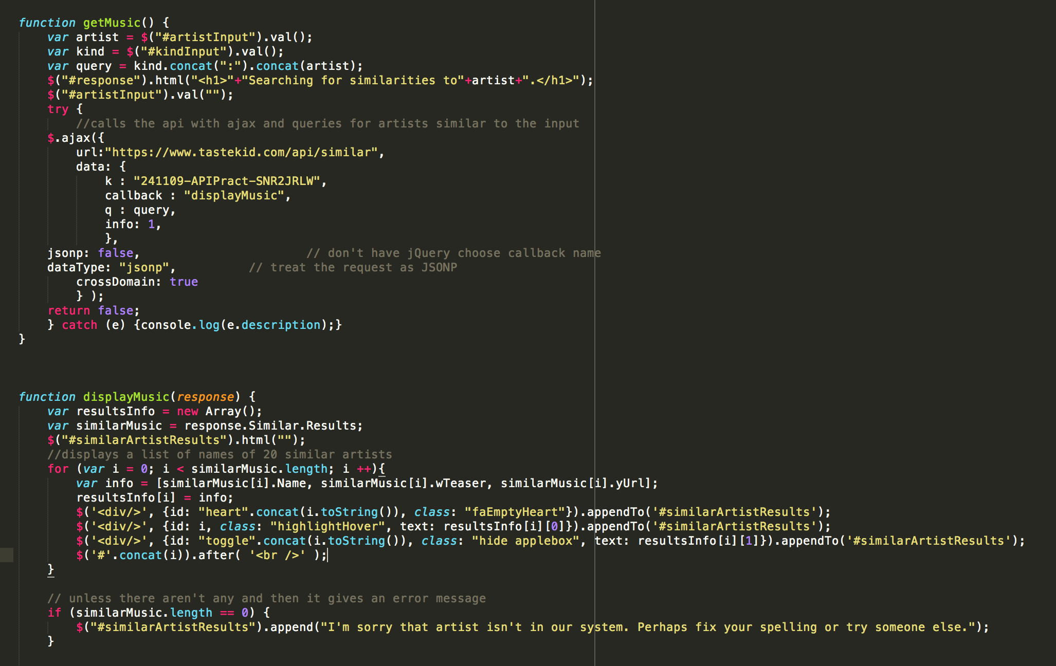

1. The user has many points of interaction. The three main GUI interactions are:
   1. Submitting the form to get the API data (as shown above)
   2. Choosing which results are their favorites

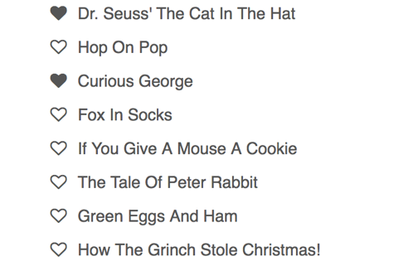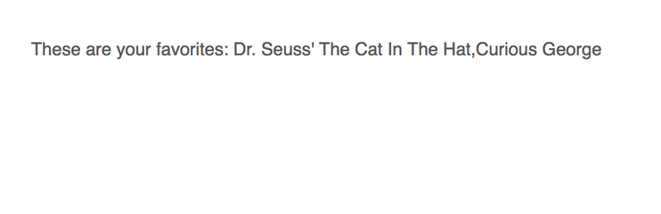

* 1. Clicking on the names of the results to see more information and scroll through the results.

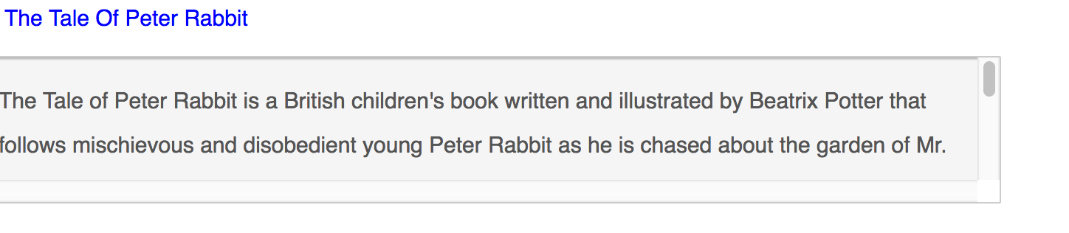

1. I used many instances of jQuery some of these are: .html(), .val(), .appendTo(), .append(), .prepend(), .toggleClass, .removeClass(), .addClass(), .after()

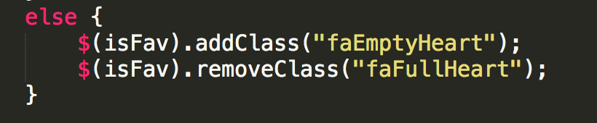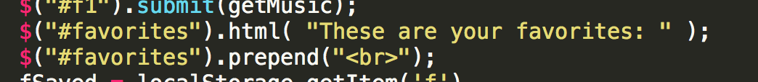

1. I separated my files into folders for JS, CSS, Images, etc.

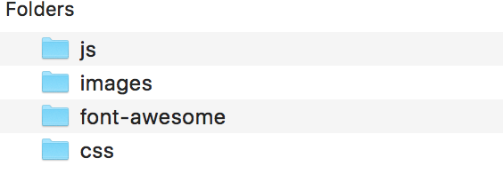

1. I included comments in my javascript where necessary to help explain my code. I also tried to self-document by using good variable names.

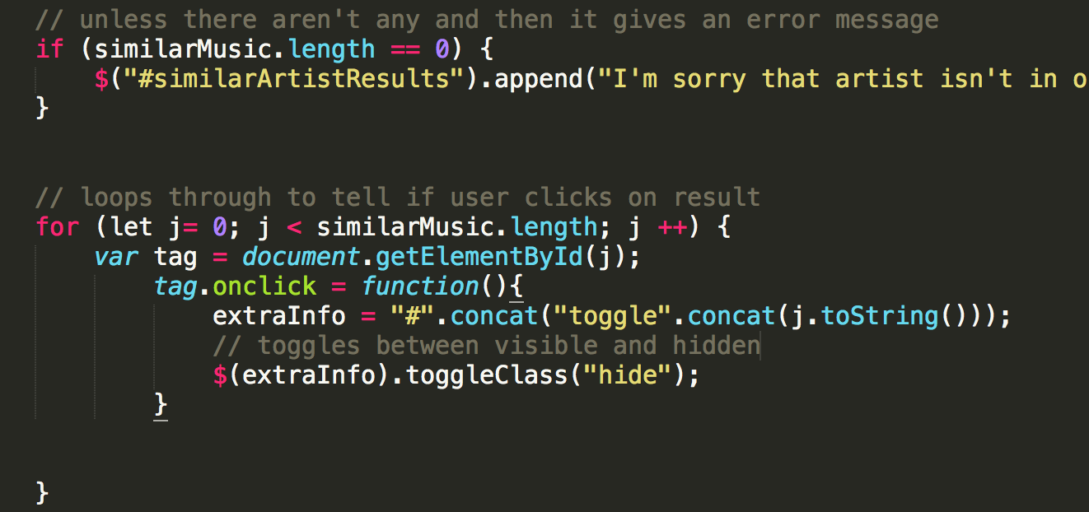

BONUS: I spent a great deal amount of time researching CSS and JQuery to make this a nice application. I included some font-awesome icons and used some Bootstrap templates. I even learned how to use local storage so that the favorites clicked could be permanently stored. I think my application demonstrates both useful creativity and good design.

NOTE: Depending on which browser and how local storage is set up the favorites page may not work as expected. This may very from device to device and this didn’t seem like a big enough project or problem to worry about it.